**Assignment: NOSQL**

**1.Create Hbase Table With One Coloumn Family And Insert The Data Randomly And Retrieve The Data With Versions .**

hbase shell

create 'students','details'

put 'students','row1','details:lastname','Deo'

put 'students','row2','details:lastname','Khan'

put 'students','row3','details:lastname','Bacchan'

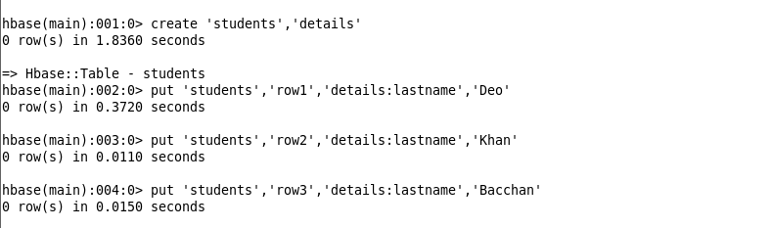

get ‘students’, 'row1', {COLUMN => 'details:Lastname', VERSIONS => 3}

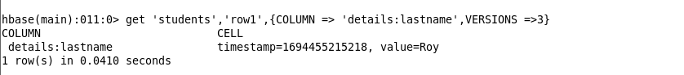

**2.Create Hbase Table With Same Row Key And Two Column Familys And Retrieve The Data With Specific Columns By Region Wise**

create 'employee_data', 'personal', 'professional'

put 'employee_data', 'region_A_employee1', 'personal:name', 'John Doe'

put 'employee_data', 'region_B_employee2', 'professional:position', 'Software Engineer'

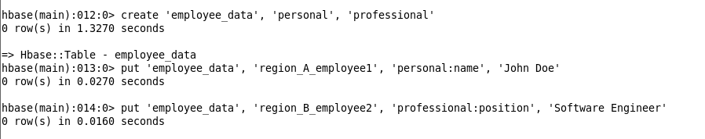

scan 'employee_data', {FILTER => "(PrefixFilter('region_A_') AND ColumnPrefixFilter('personal:'))"}

scan 'employee_data', {FILTER => "(PrefixFilter('region_B_') AND ColumnPrefixFilter('professional:'))"}

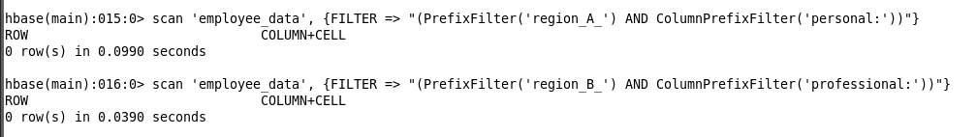

**Find The Difference Of Database With Nosql Db**

|  |  |
| --- | --- |
| **SQL** | **NoSQL** |
| RELATIONAL DATABASE MANAGEMENT SYSTEM (RDBMS) | Non-relational or distributed database system. |
| These databases have fixed or static or predefined schema | They have a dynamic schema |
| These databases are not suited for hierarchical data storage. | These databases are best suited for hierarchical data storage. |
| These databases are best suited for complex queries | These databases are not so good for complex queries |
| Vertically Scalable | Horizontally scalable |
| Follows ACID property | Follows CAP(consistency, availability, partition tolerance) |
| **Examples:**[MySQL](https://www.geeksforgeeks.org/mysql-common-mysql-queries/), [PostgreSQL](https://www.geeksforgeeks.org/what-is-postgresql-introduction/), Oracle, MS-SQL Server, etc | **Examples:**[MongoDB](https://www.geeksforgeeks.org/mongodb-tutorial/), [GraphQL](https://www.geeksforgeeks.org/graphql-query/), [HBase](https://www.geeksforgeeks.org/architecture-of-hbase/), [Neo4j](https://www.geeksforgeeks.org/neo4j-introduction/),[Cassandra,](https://www.geeksforgeeks.org/apache-cassandra-nosql-database/) etc |